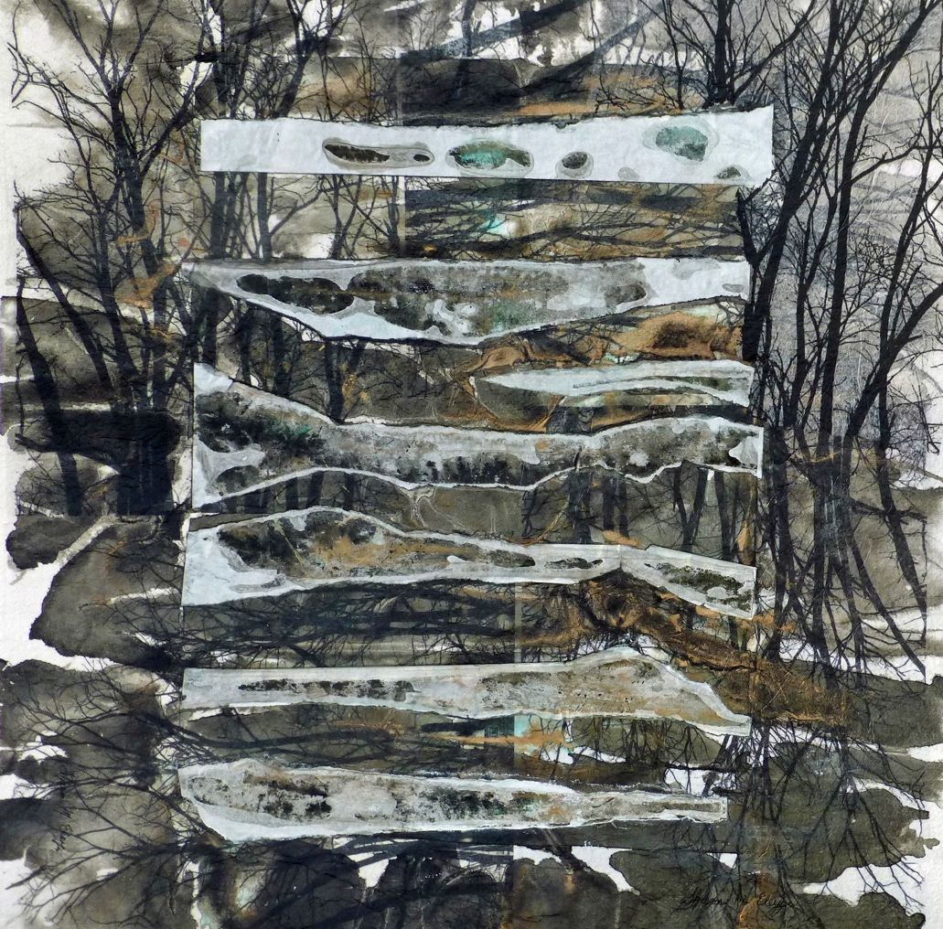

Enchanted Forest Poem II by Sharon Eley
The enchanted forest calls me
To walk under its sheltering canopy,
To listen to the leaves being stirred by the breeze,
To watch quietly while nature around me thrives…
Leaving the stress of life behind me.
I walk quietly to absorb its surroundings
And know who it was who created
Such a tranquil, peaceful escape for us to relax in.
The enchanted forest beckons me on
To relax, to breathe deeply, to experience its gifts.
I feel renewed, refreshed, invigorated
To carry on, to walk enlightened, full of understanding…
Knowing I have been gifted the benefits
Of
The Enchanted Forest.

