Dividing the Yarrow 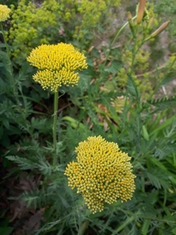

Digging with a fork, I divide the yarrow plant in fall
My intention is to multiply, to make of yarrow more,
So I may enjoy her golden clusters standing tall
In new garden places than before.

To stay or go—the Yarrow doesn’t say.
So, I move her division to another flower bed.
Does Yarrow feel the loss, as snow and ice give way
To mud and the long dry spring ahead?

Now, walking the yard in summer’s early light,
I see that the two yarrows have survived.
Mama Yarrow is poised to reveal her golden bright,
while sadly, her offspring is barely alive.

What if Yarrow holds some precious wisdom?
She knows why one plant falters while another grows.
Recognizes the shy ones whose face are hidden.
and the extroverts who crave the bright sun.

We can learn from the Yarrow and her tribe,
And pause to listen, as we are alive,
And discover our truth, from deep inside.
What conditions will make us thrive?

Robin Brooks
June 30, 2021, revised January 19, 2022
After Rhina P. Espaillat’s poem “Turning the Begonia” from Her Place in these Designs, Truman State University Press, 2008.

